**JavaScript – Tutorial**

07)

<!DOCTYPE html>

<html>

<head>

<title>Mathematical Operations</title>

</head>

<body>

<h1>Mathematical Operations</h1>

<button onclick="performOperations()">Perform Operations</button>

<script>

function performOperations() {

const num1 = parseFloat(prompt("Enter the first number:"));

const num2 = parseFloat(prompt("Enter the second number:"));

if (isNaN(num1) || isNaN(num2)) {

alert("Invalid input. Please enter valid numbers.");

return;

}

const addition = num1 + num2;

const subtraction = num1 - num2;

const multiplication = num1 * num2;

let division;

if (num2 === 0) {

division = "Cannot divide by zero.";

} else {

division = num1 / num2;

}

alert(`Addition: ${addition}\nSubtraction: ${subtraction}\nMultiplication: ${multiplication}\nDivision: ${division}`);

}

</script>

</body>

</html>

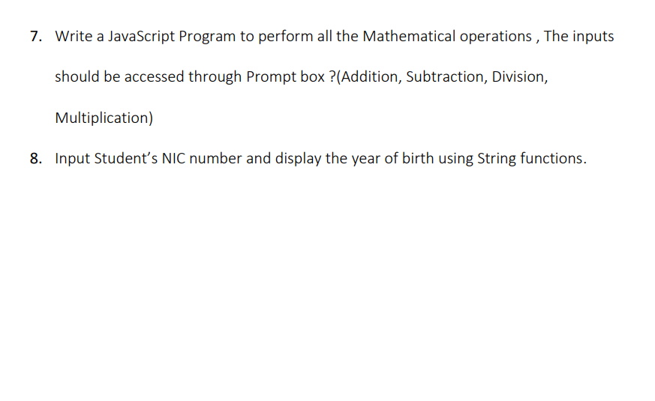

08)

<!DOCTYPE html>

<html>

<head>

<title>Year of Birth from NIC Number</title>

</head>

<body>

<h1>Enter Student's NIC Number</h1>

<input type="text" id="nicInput">

<button onclick="getYearOfBirth()">Get Year of Birth</button>

<script>

function getYearOfBirth() {

const nicNumber = document.getElementById("nicInput").value;

if (nicNumber.length !== 10 || !isNumeric(nicNumber.substring(0, 9))) {

alert("Invalid NIC number. Please enter a valid NIC number.");

return;

}

const yearOfBirth = "19" + nicNumber.substring(0, 2);

alert(`Year of Birth: ${yearOfBirth}`);

}

function isNumeric(str) {

return /^\d+$/.test(str);

}

</script>

</body>

</html>